In this document we use the router 7200 because it permit us try the configuration of our VLANs. As well we will use the GNS3 program version 1.3.13 for the architecture of our computer (32 bits).

We procedure to download the image ISO router 7200 of internet. After, click in Edit > Preferences > IOS routers > New >Browse.. Select the image ISO of our router and click in Next and configure the name and the platform. Click in Ok and already we can install our router.

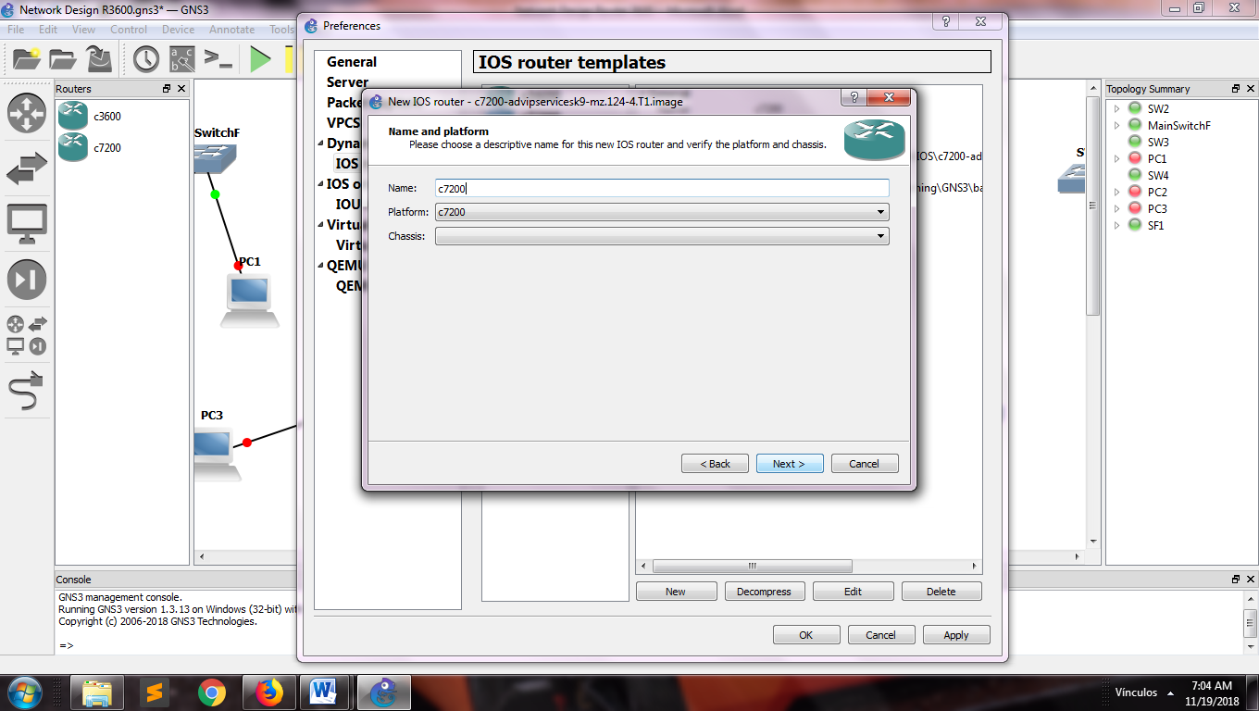

1. View to install the ISO image

Drag and drop the routers into the workspace and the change its name for identify better.

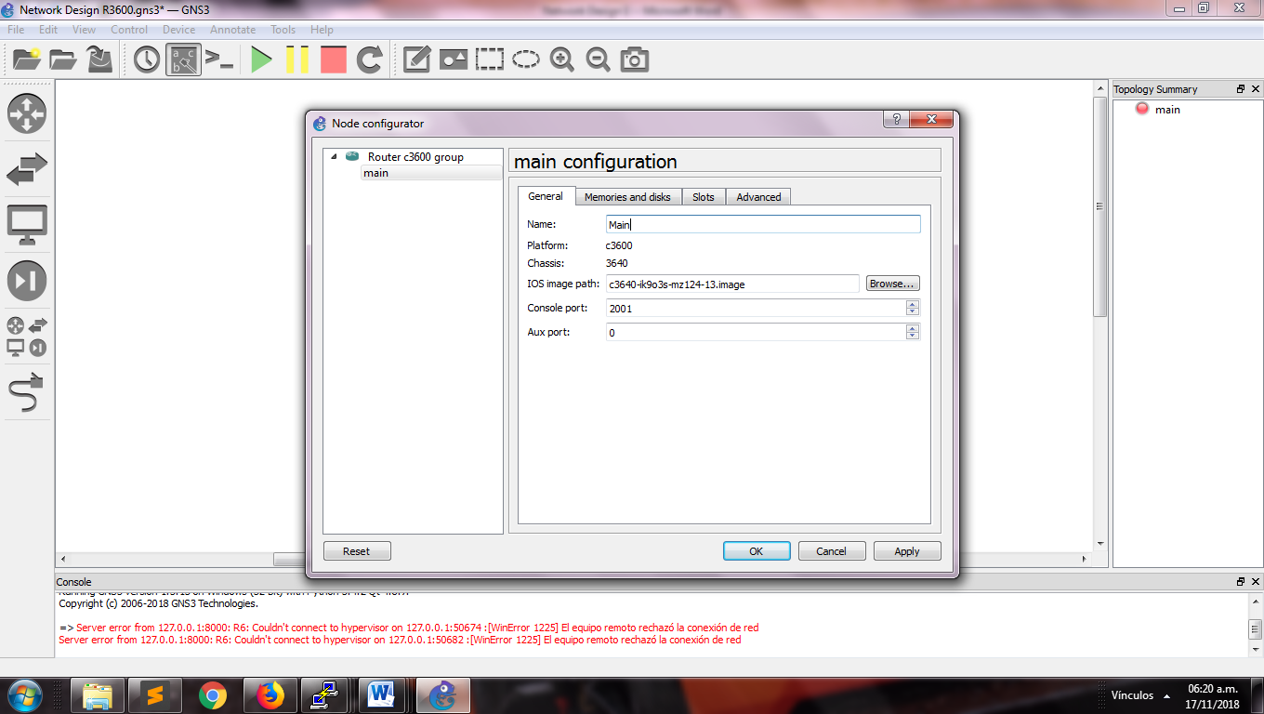

1. View main router configuration

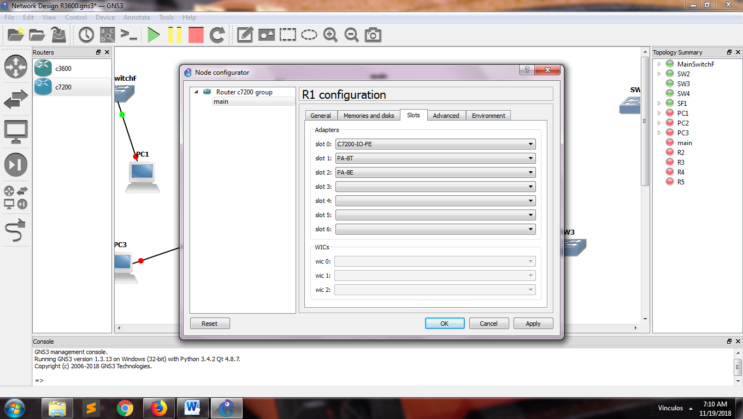

1. View configuration router slots

We use the star topology for our design with a router main that connect with the routers of each department through a cable.

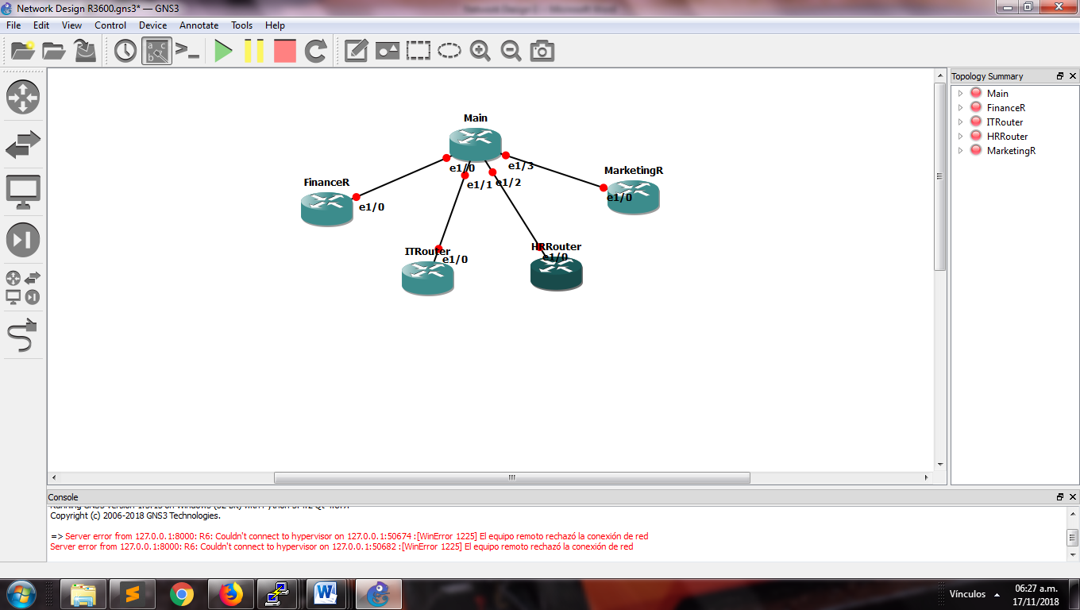

1. View connection of routers

In all the routers, we make click in the option Auto Idle-PC for calculate automatically the possibility of CPU usage of the computer.

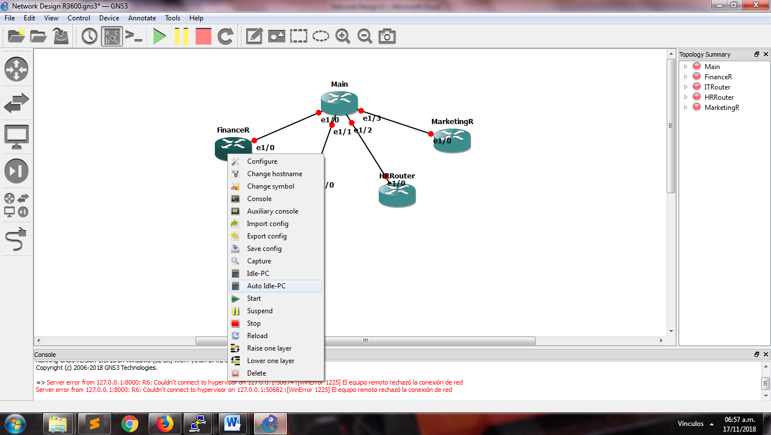

1. Select Auto Idle-PC

We check the configuration in each router for try the connection, using the ip addres showed below in the table 1 and typing the next lines commands into the console of each department router.

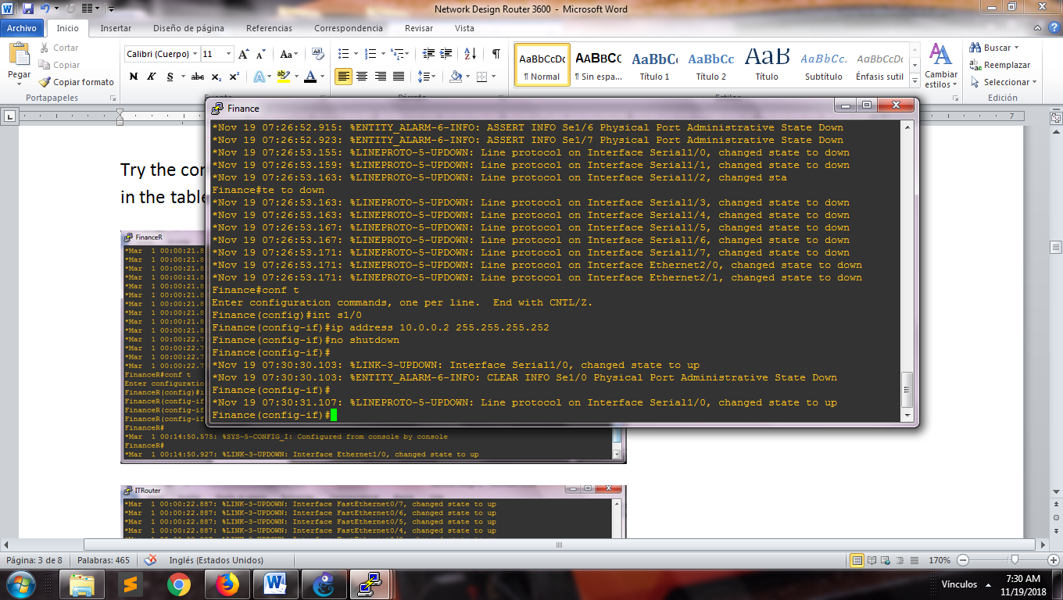

1. Command lines for assignment ip address in WAN

For the main router, we configure the interfaces (s1/0, s1/1, s1/2, s1/3), in the following way and turn on each one

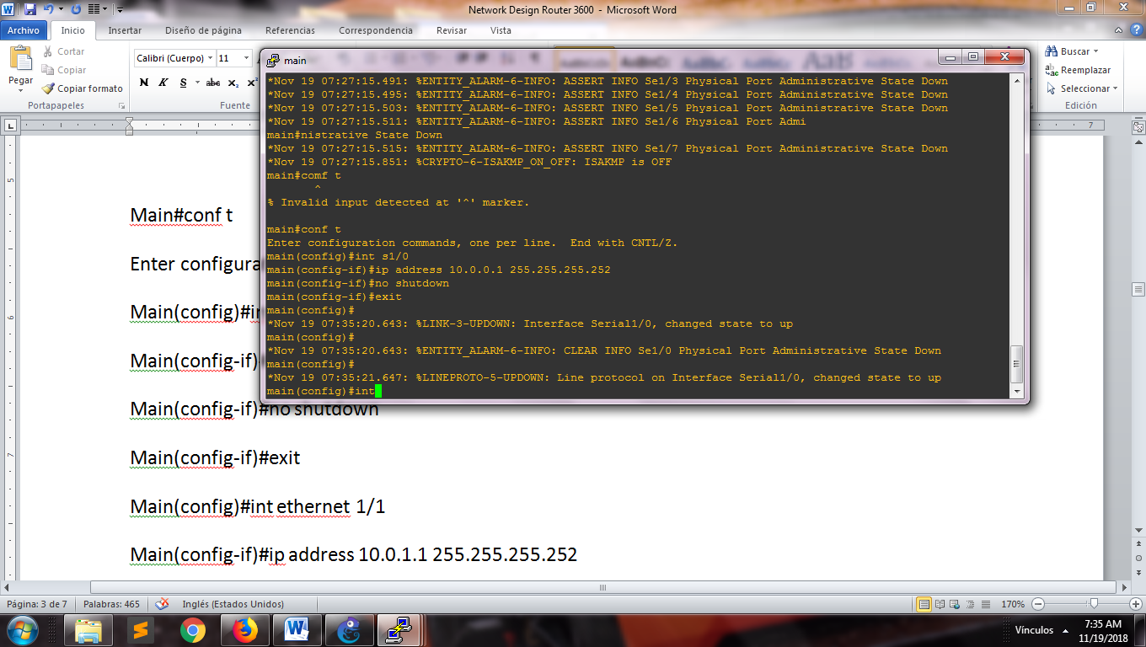

1. Command lines for assignment ip address in WAN

|  |  |
| --- | --- |
| Router | IP address |
| FinanceR | 10.0.0.2/30 |
| ITRouter | 10.0.1.2/30 |
| HRRouter | 10.0.2.2/30 |
| MarketingRouter | 10.0.3.2/30 |

Table 1 with the ip address of each router of the department

We assess the connection making ping between the routers. The result showed that the main router can communicate with the others routers.

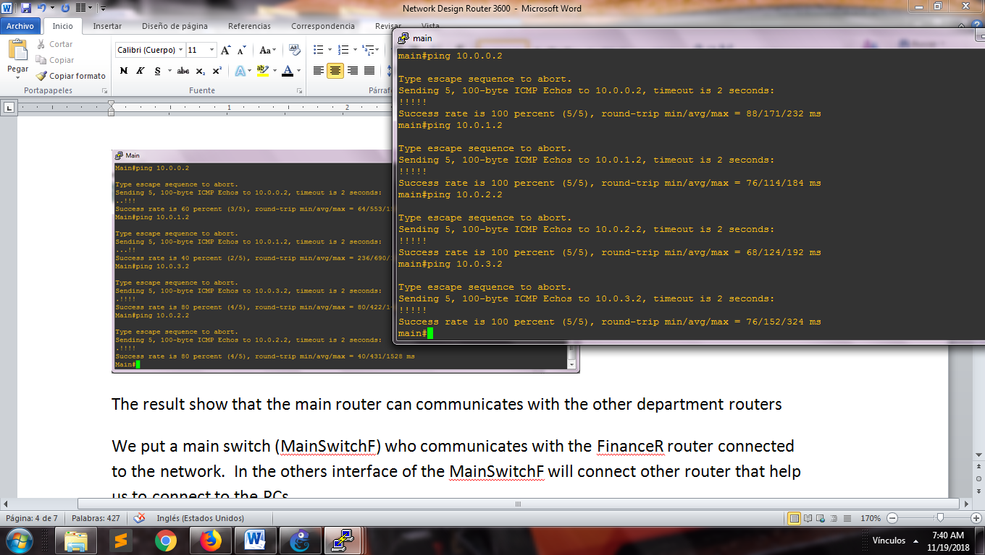

1. View of success connection between the routers

We put a main switch (MainSwitchF) who communicates with the FinanceR router connected to the network. In the others interface of the MainSwitchF will connect other router that help us to connect to the PCs.

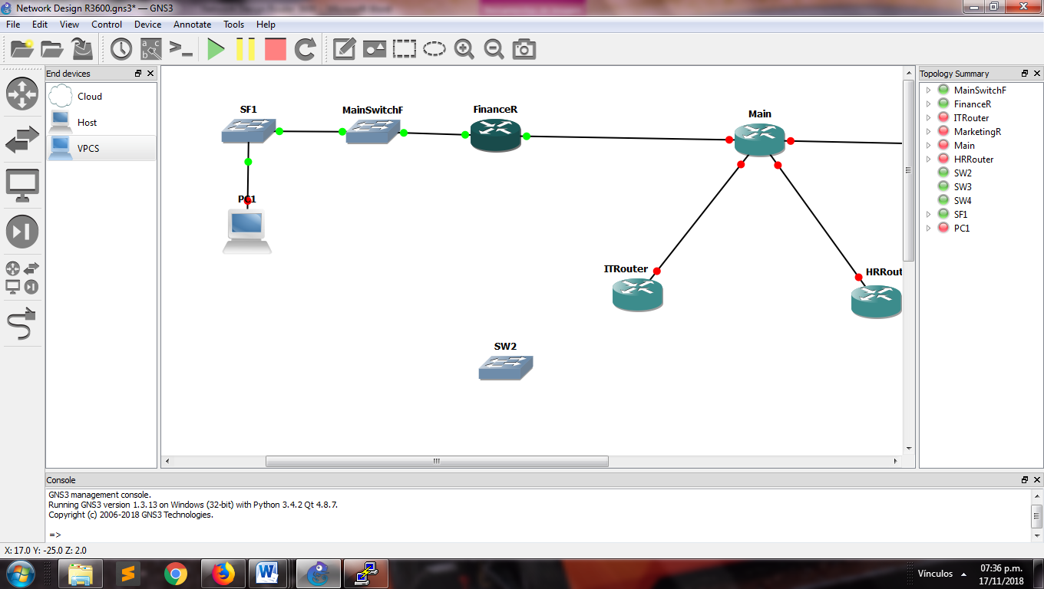

1. View schema of connection

Now we configure the switches with the name of the VLANs that it will be used into of each department.

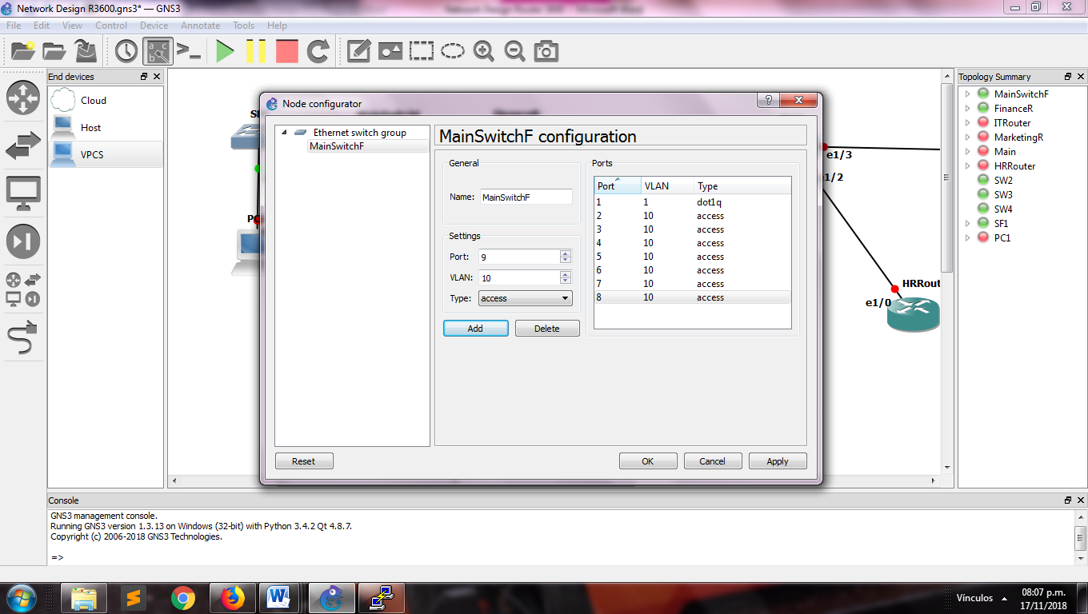

1. View configuration of the VLAN into of the switches

Into the console of the IT router we type the next command lines for make the configuration of the VLANs:

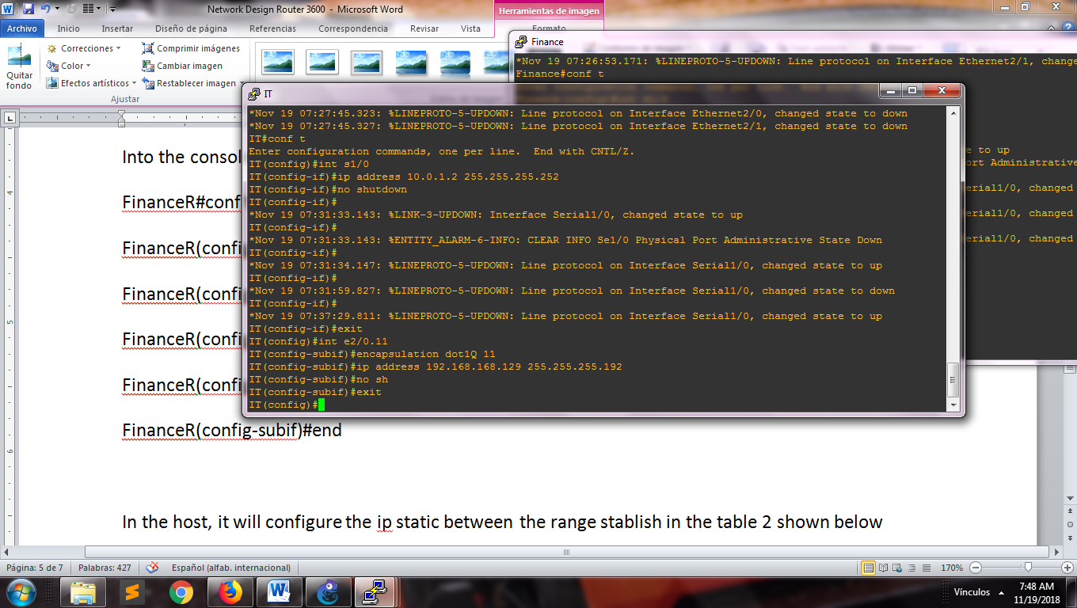

1. Command lines for configure the VLANs inside of the routers

The next table, show the number of each VLAN configured inside of our network design and the department belong.

|  |  |
| --- | --- |
| Department | VLAN number |
| Finance | 10 |
| Information Technology | 11 |
| Human Resources | 12 |
| Marketing | 13 |

Table 2 with VLAN number of each department

In the host, it will configure the ip static between the range stablish in the table 3 shown below, this table was obtained through subnetting.

|  |  |  |  |  |
| --- | --- | --- | --- | --- |
| Nº | Requested host | Network address | Decimal mask | Broadcast  address |
| 1 | 69 | 192.168.168.0/25 | 255.255.255.128 | 192.168.168.127 |
| 2 | 39 | 192.168.168.128/26 | 255.255.255.192 | 192.168.168.191 |
| 3 | 19 | 192.168.168.192/27 | 255.255.255.224 | 192.168.168.223 |
| 4 | 11 | 192.168.168.224/28 | 255.255.255.240 | 192.168.168.239 |

Table 3 with the ip address

The ip table configured in the main router is shown below with the address that belongs to each interface:

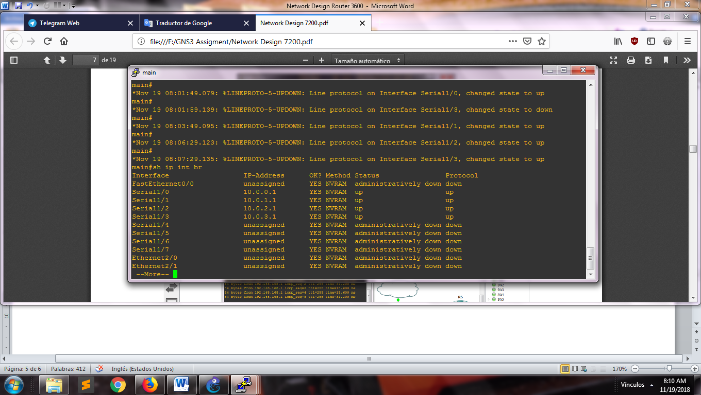

1. The command line used for generated this table is **sh ip int br**

The next step is to configure the route that the routers will use for send the packages. For the main router are the follow:

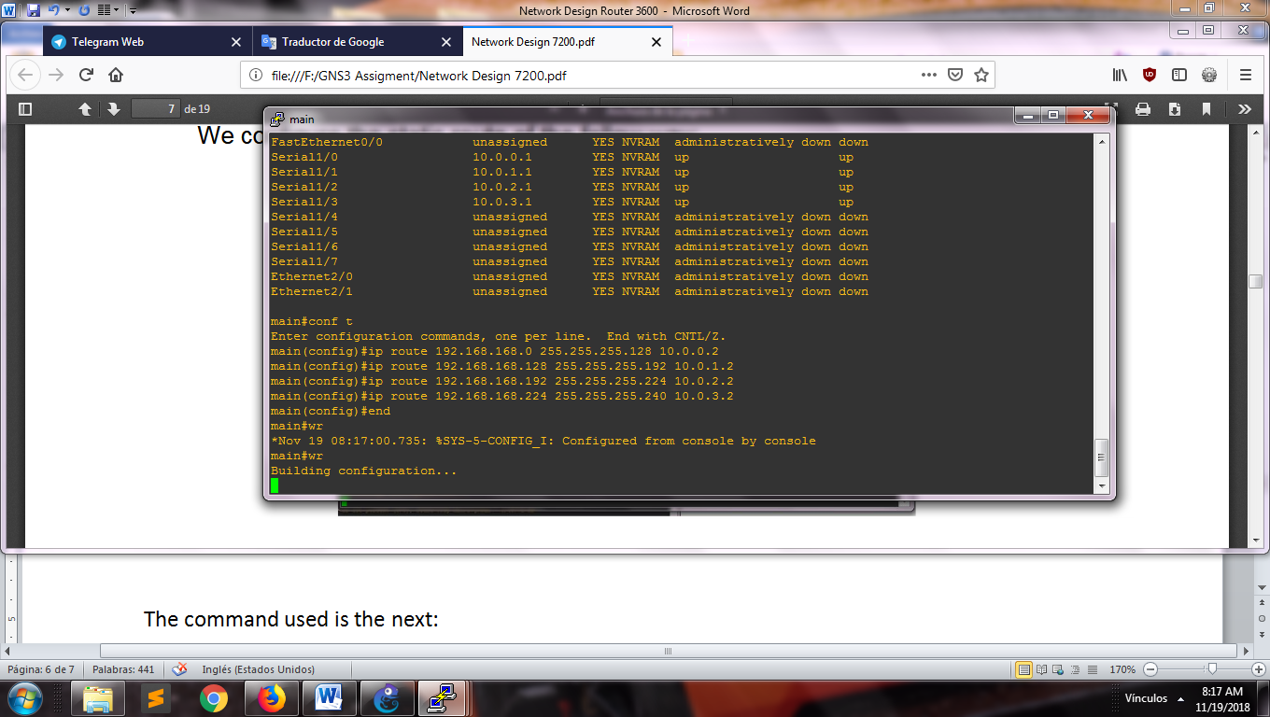

1. Command lines for the main routing

For configure the router of each department, we use the next lines inside its console:

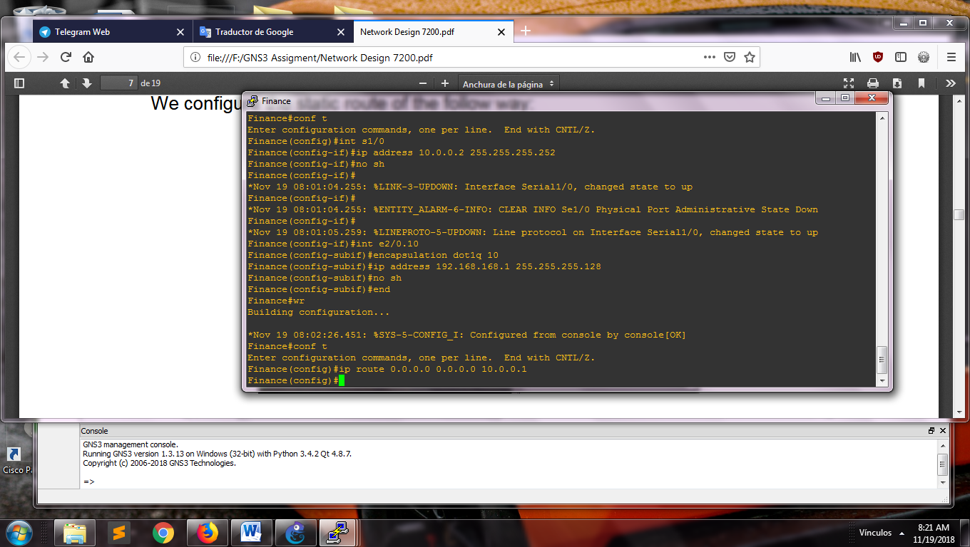

1. Command lines for the department routing

The ip addresses belong to printer and server will be static to avoid guessing this address for the communication toward these equipment. We enter in the console of the component and typing the word ip follow of the ip address, the mask and the gateway. To finish, we typing save to store the configuration made.

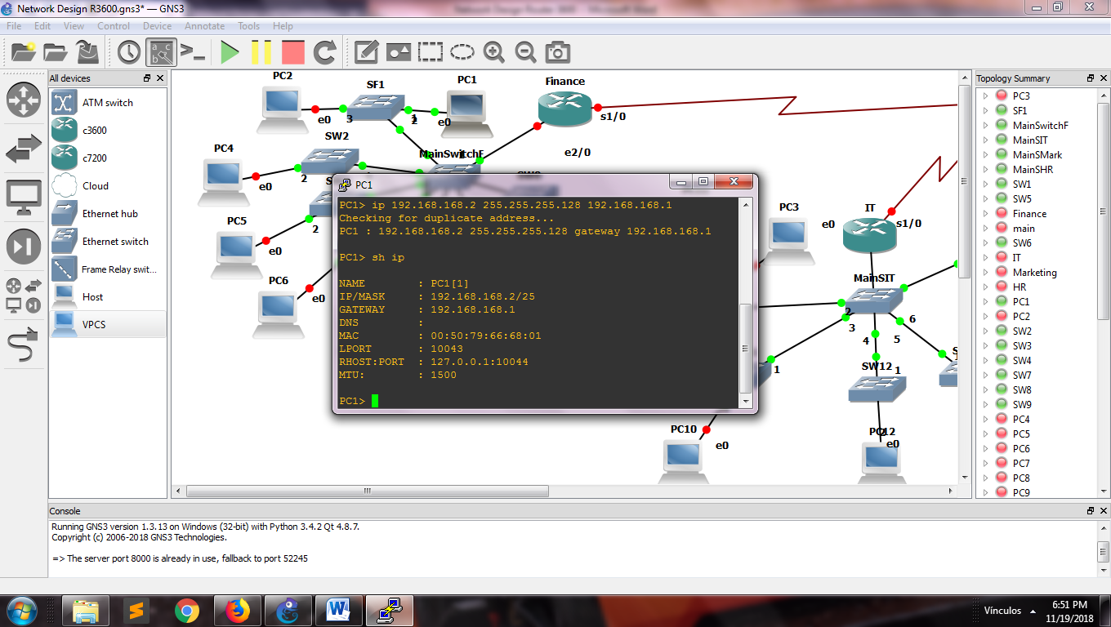

1. Command line for assignment the static ip address

For identify visually the printer and the server, we can change the image that represent it. We make right click over the host, click in change symbol and select the image corresponding:

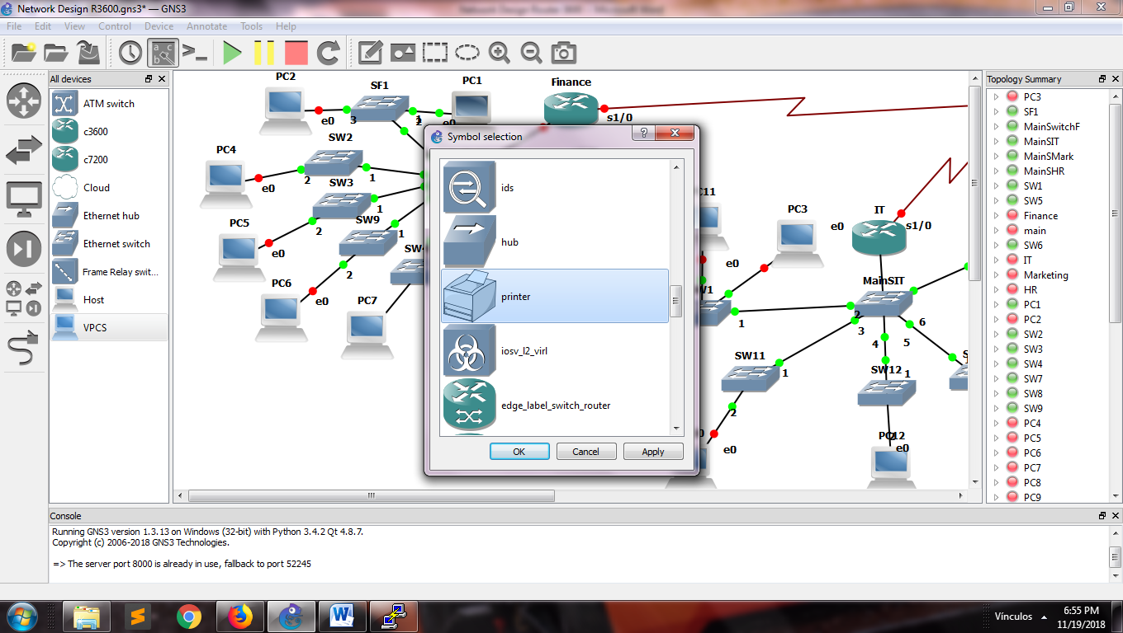

1. View for configure the component image

Now assignment the ip address for each host through DHCP configured in each department router, and in the same time, we exclude the ips that will be to assigned statically.

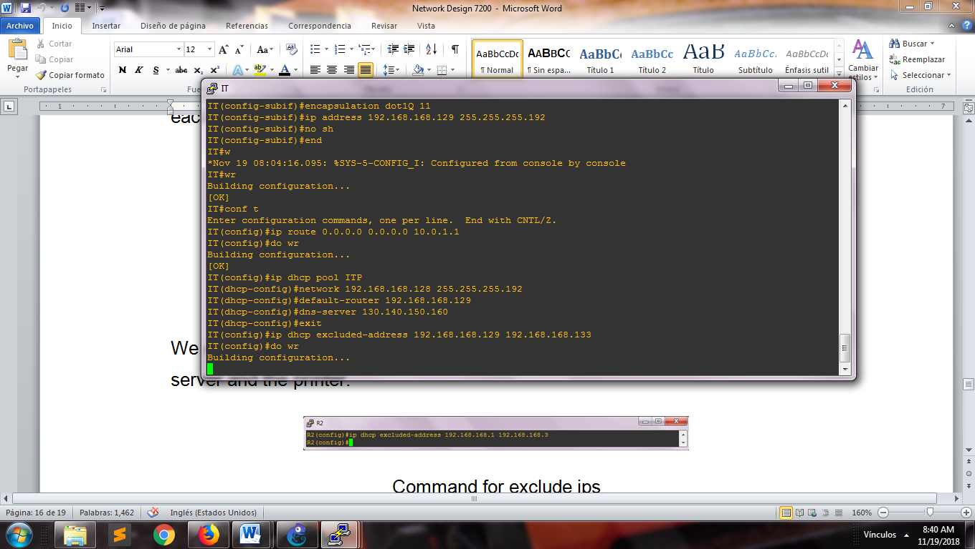

1. View to configure the DHCP for the IT department

We check the assignment the ip address in each host inside the pc console typing the next command line **dhcp**

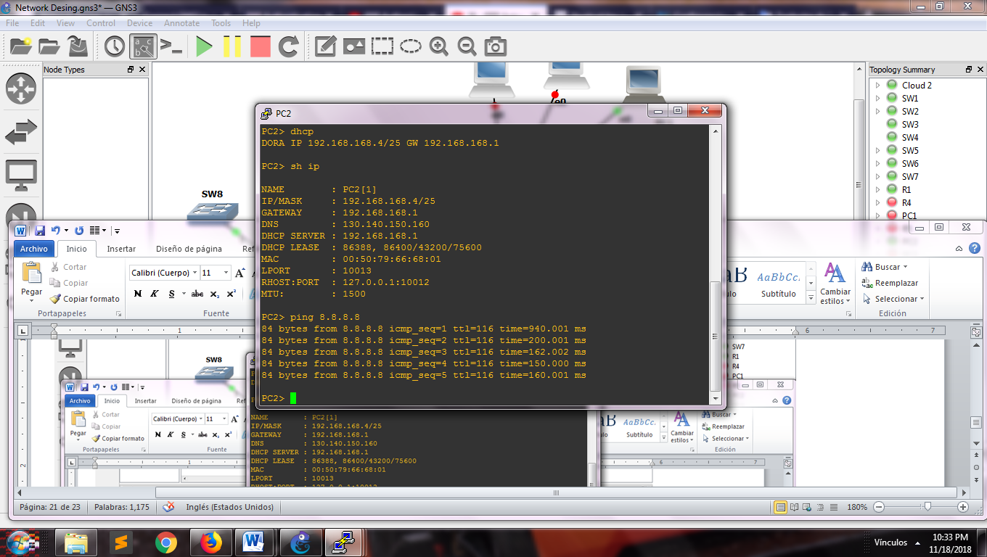

1. View the assignment ip address through of DHCP

Now we create the access lists that deny the communication between the hosts of the departments.

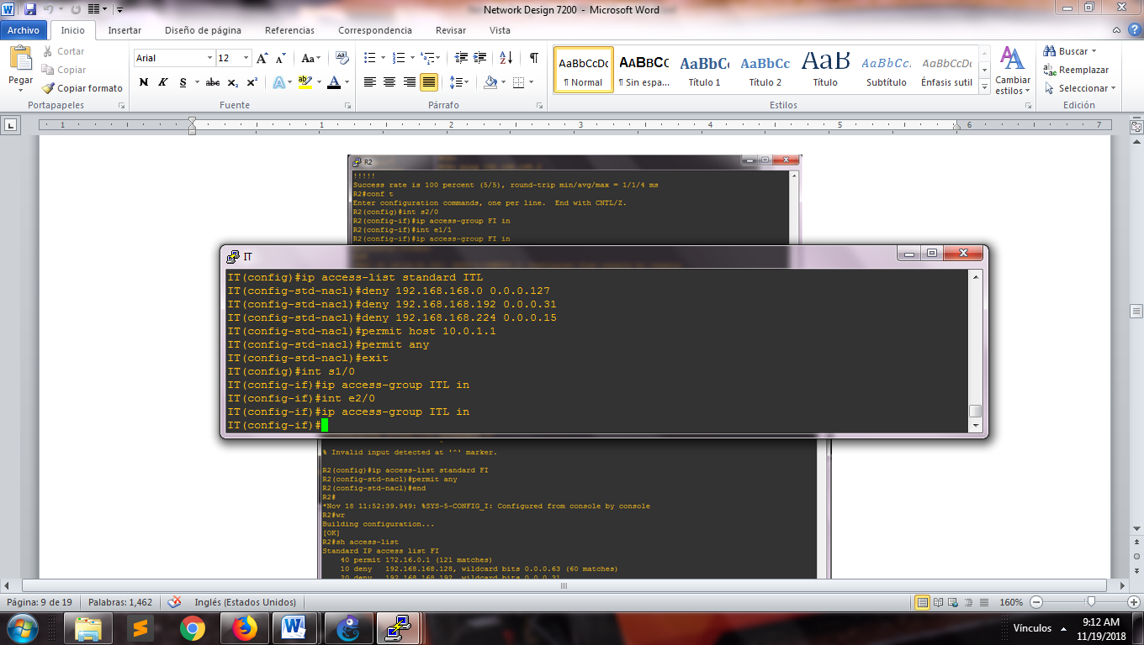

1. View to create a access list control standard for the deparment

We show the access list already created with the next command inside the console of the router:

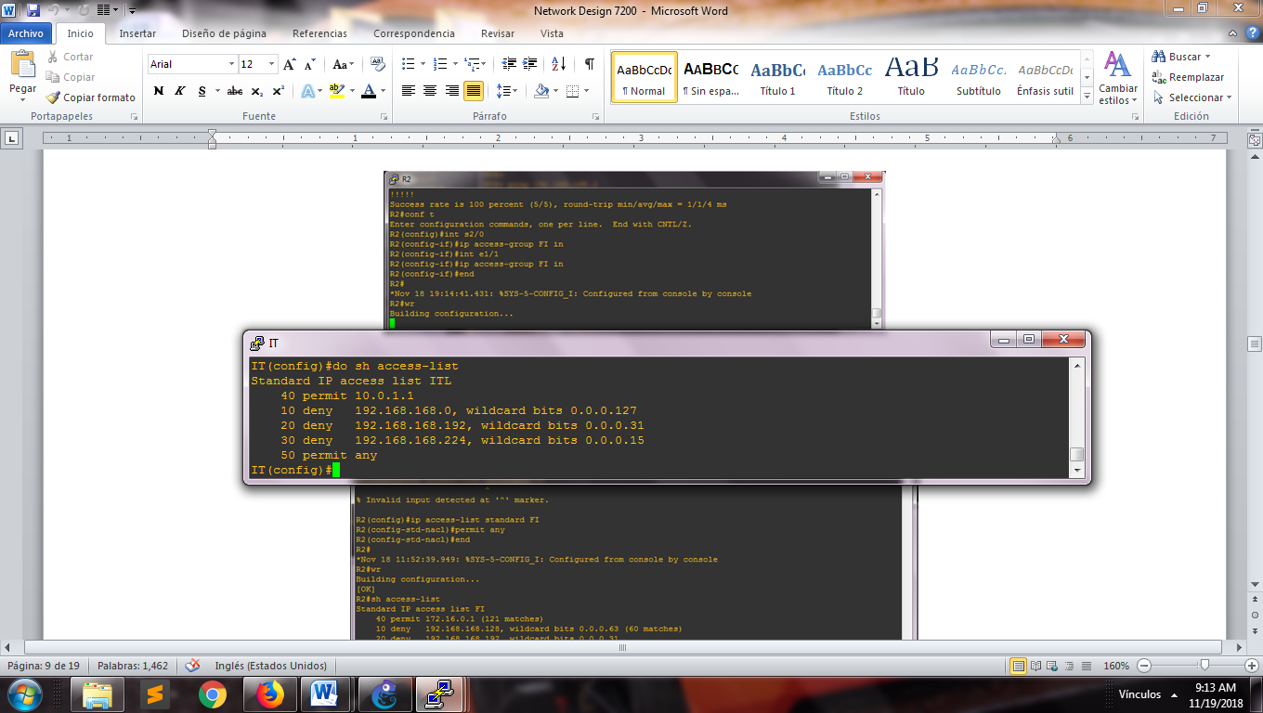

1. View access list

We configure the DNS server through the next command inside the main router

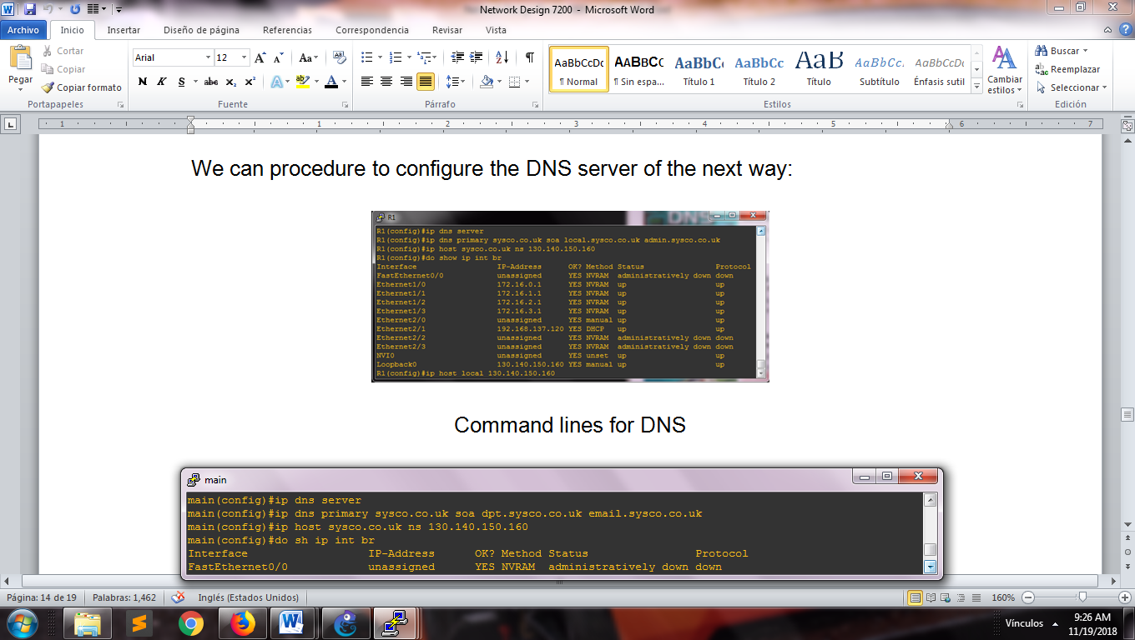

1. Command lines for configure the DNS server with the ip address public

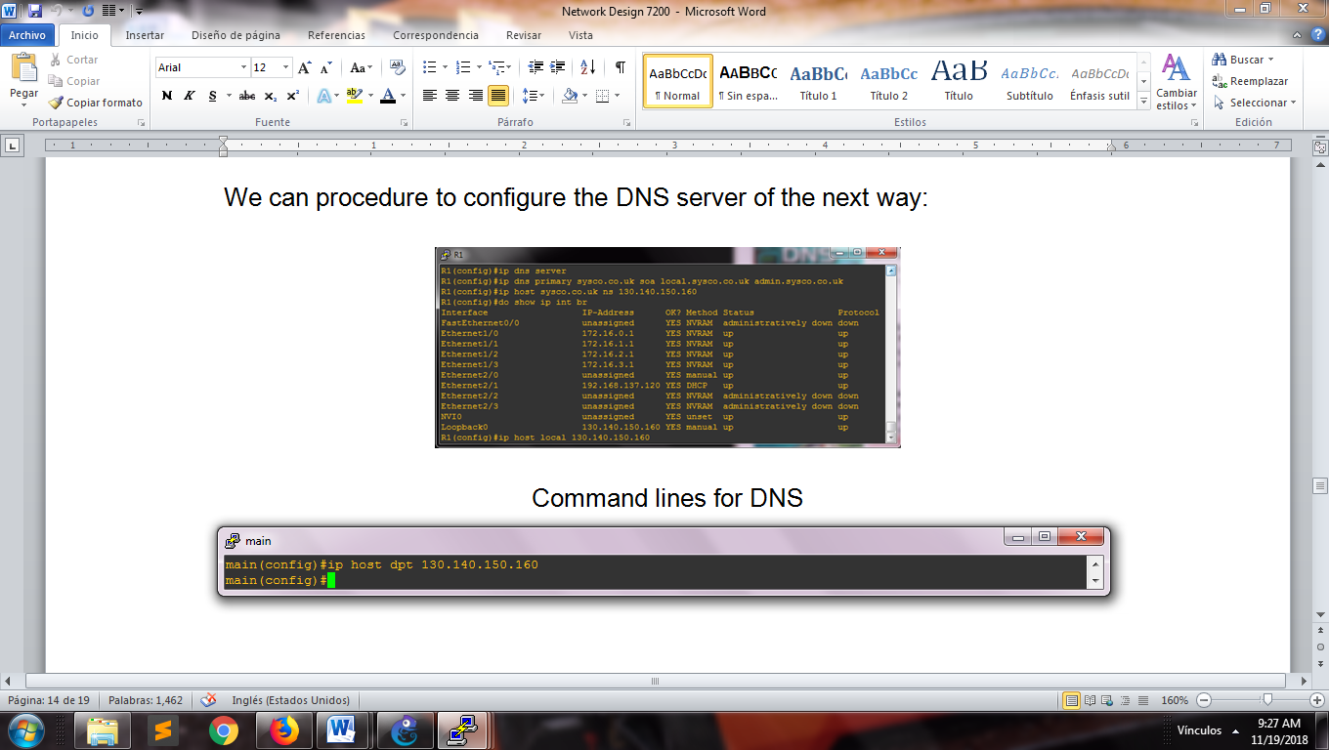

1. View assignment of the address network

In the router of each department add the next lines:

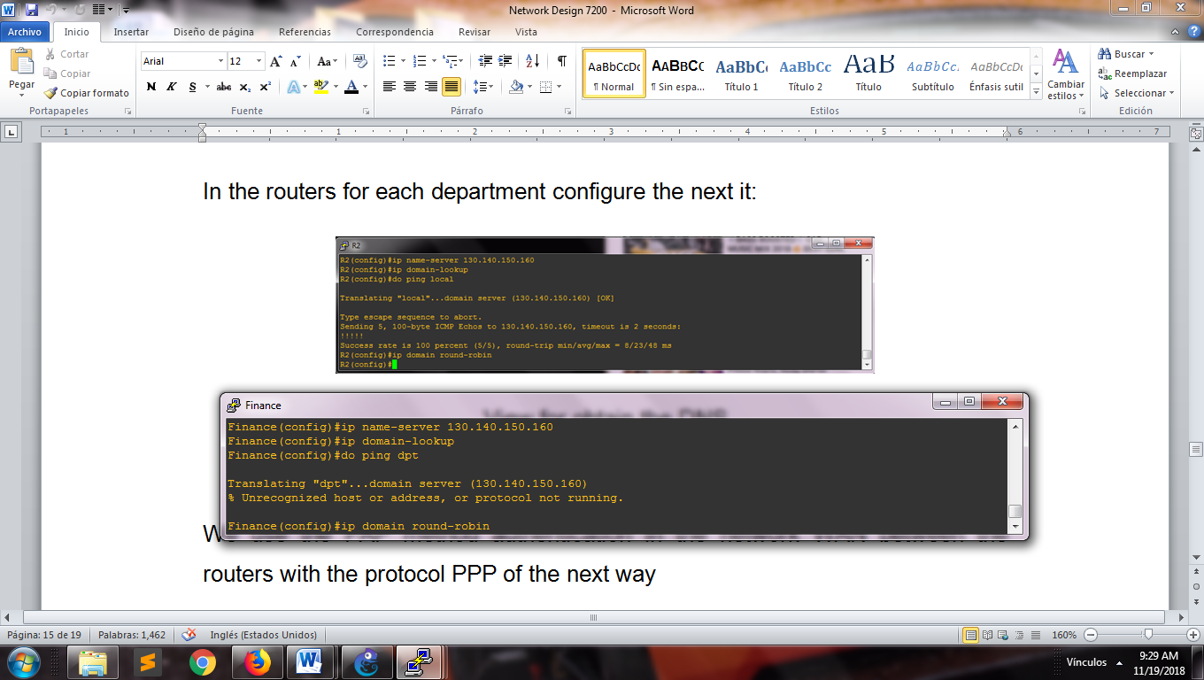

1. View of assignment the domain server

For our WAN, we use the authentication method named PAP for the connection point to point with the protocol PPP.

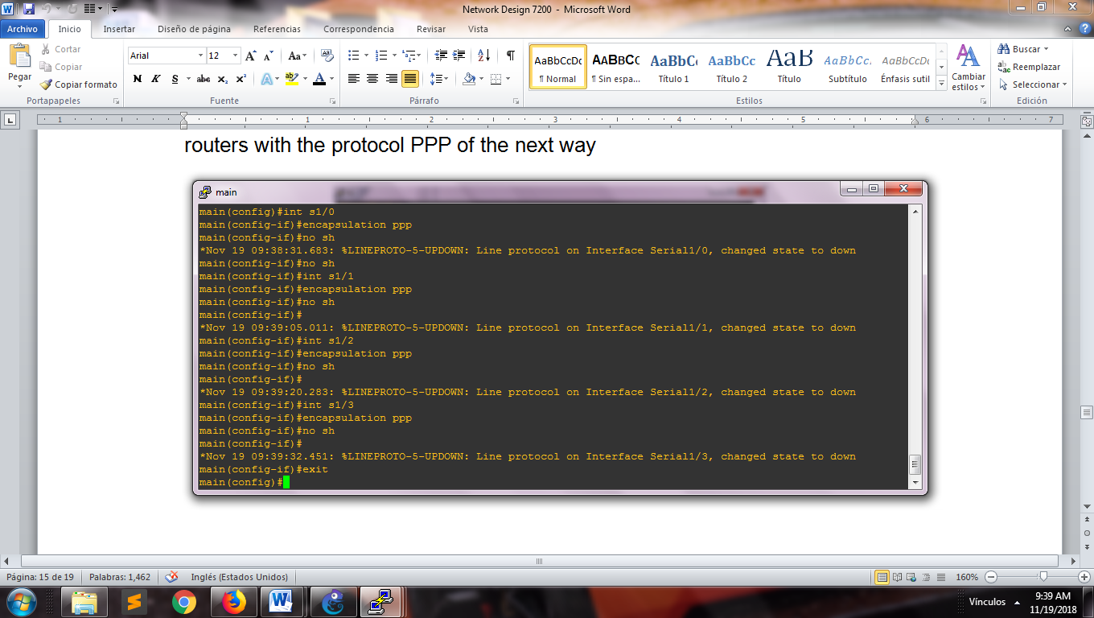

1. View encapsulation for each interface

In each router we type the next command lines for obtain the encapsulation ppp.

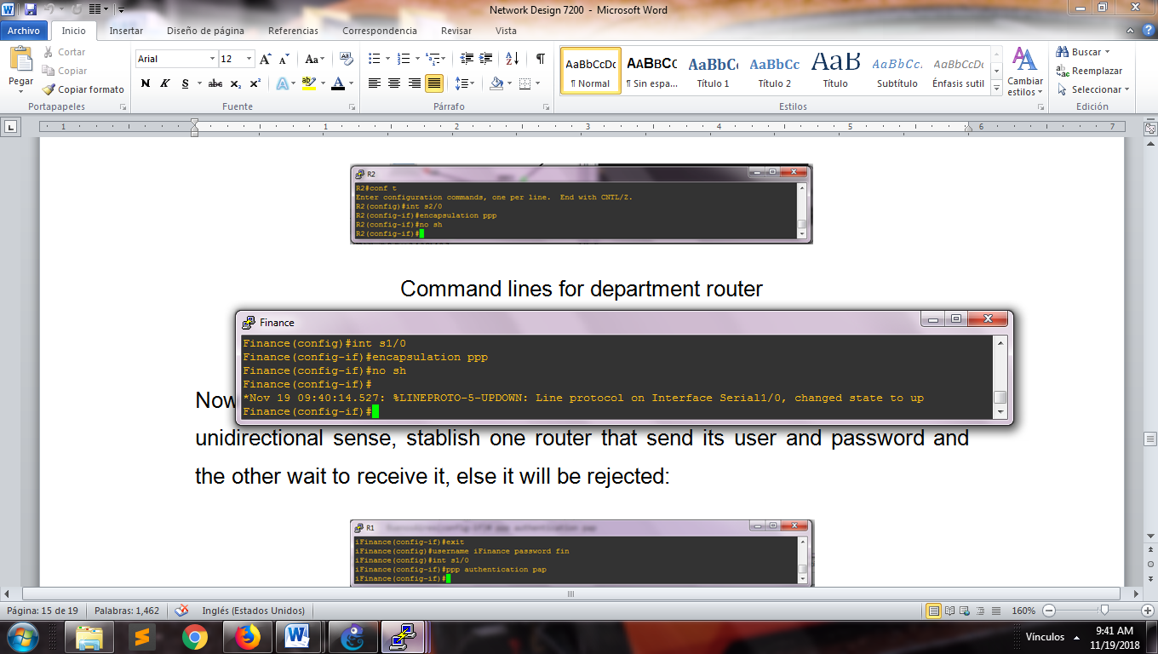

1. View encapsulation in the department router

Now configure the user with its password for do the authentication inside the network

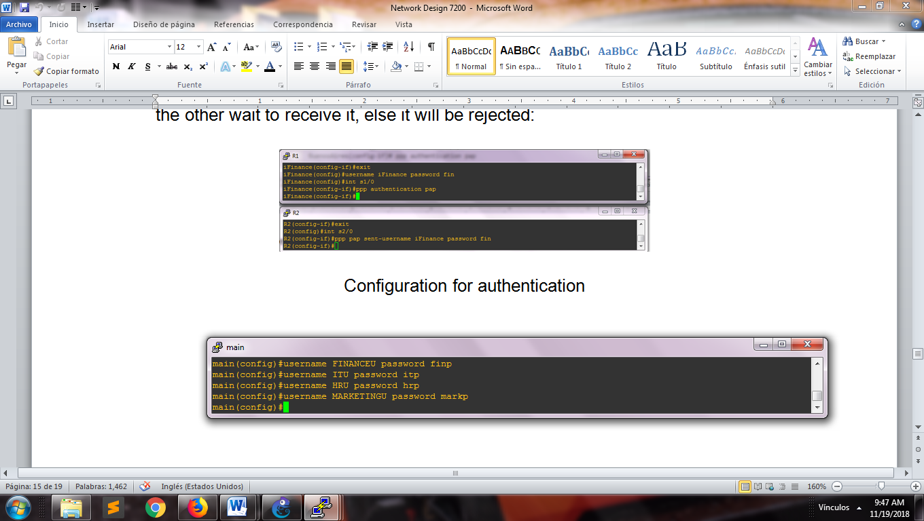

1. Command lines for make the authentication between the routers

On the department's routers, type the following command lines to send the username and password that will be authenticated.

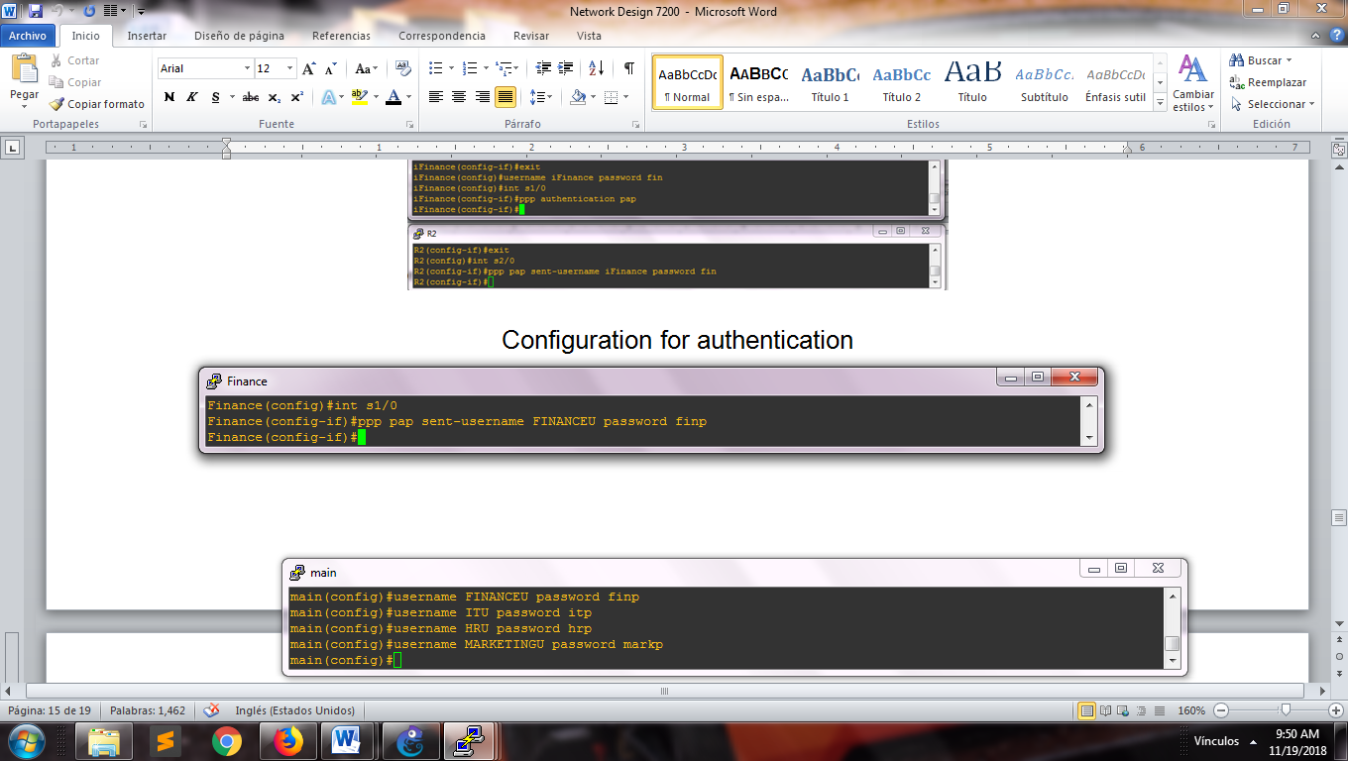

1. Command line for configuration of the username and password

We use one different ip for communicate us outside of the network, so for do this transformation we are going use a method of mapping of ip address, denominated NAT inside of our main router with the next command lines.

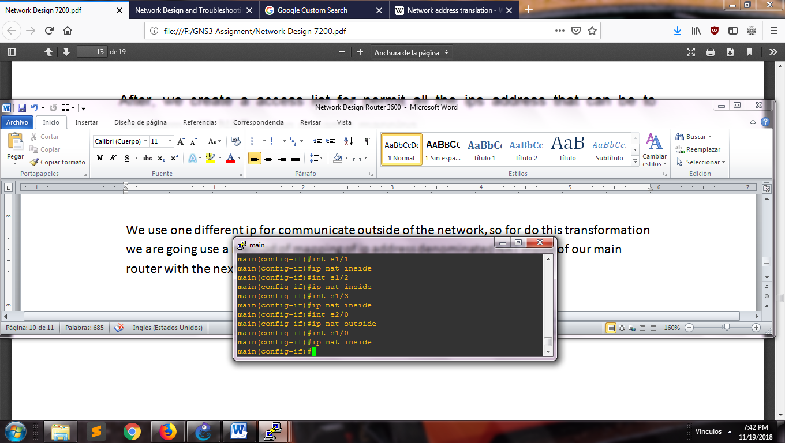

1. Command lines for the implementation of the method NAT

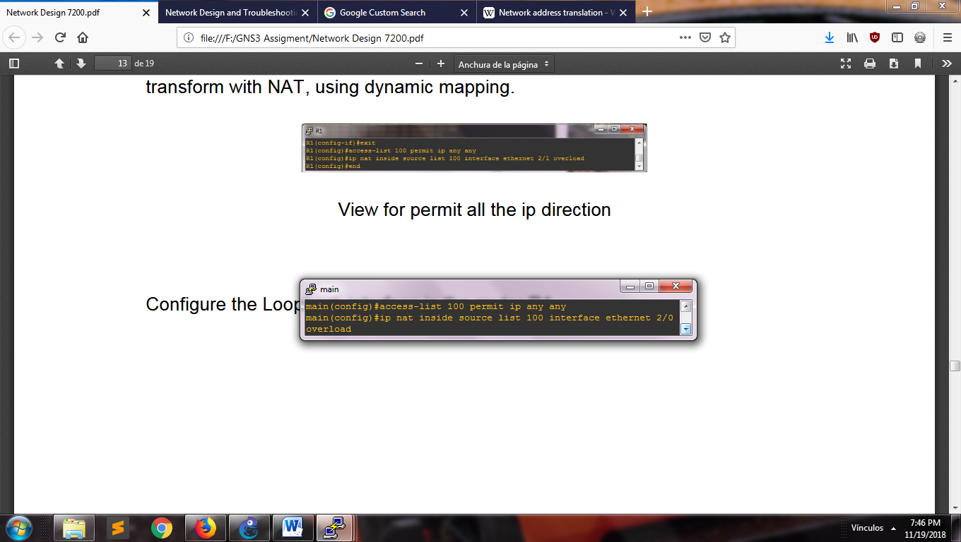

1. Command lines for the access list in the outside interface

If we want to connect to the Internet, we need to create a loopback interface for filtering packets within our network. First, we install a Loopback adapter in our computer through the network center in the control panel, this will request the connection for our provided network interface.

This loopback interface will be represented as a cloud inside our workspace which we will configure to provide of internet to our network.

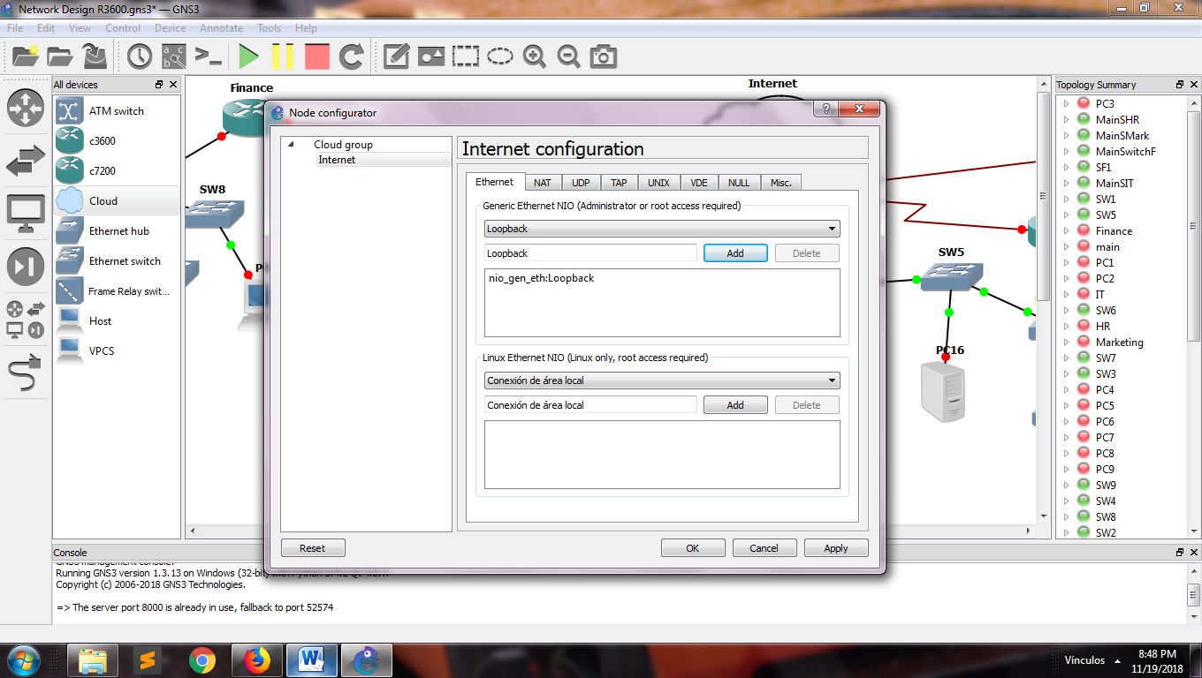

1. Views with the configuration of the Loopback interface

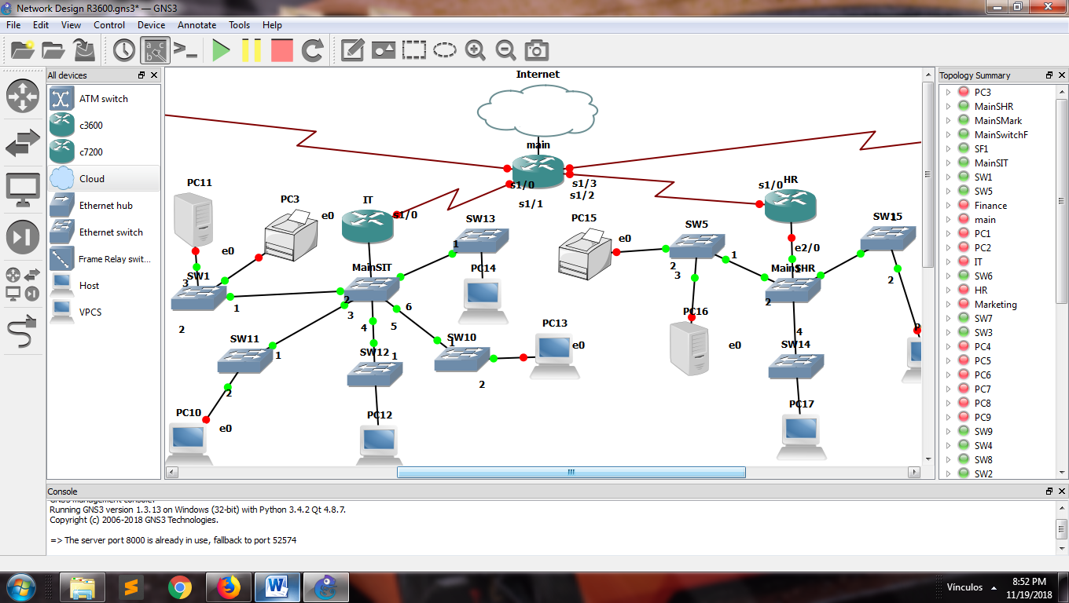

1. Views of the network connection

Now for obtain a real ip address that it connect to internet, we make a request with the next command:

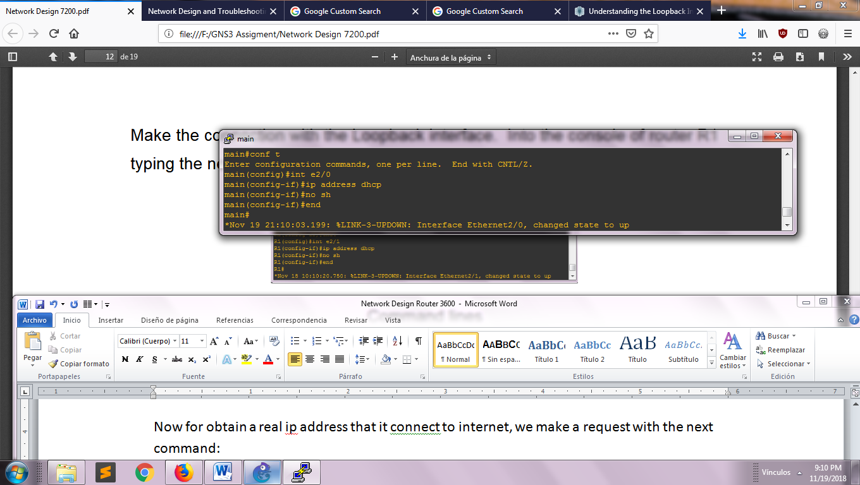

1. Command lines for doing to request of address ip

The loopback interface should be configured the next way inside of the main router:

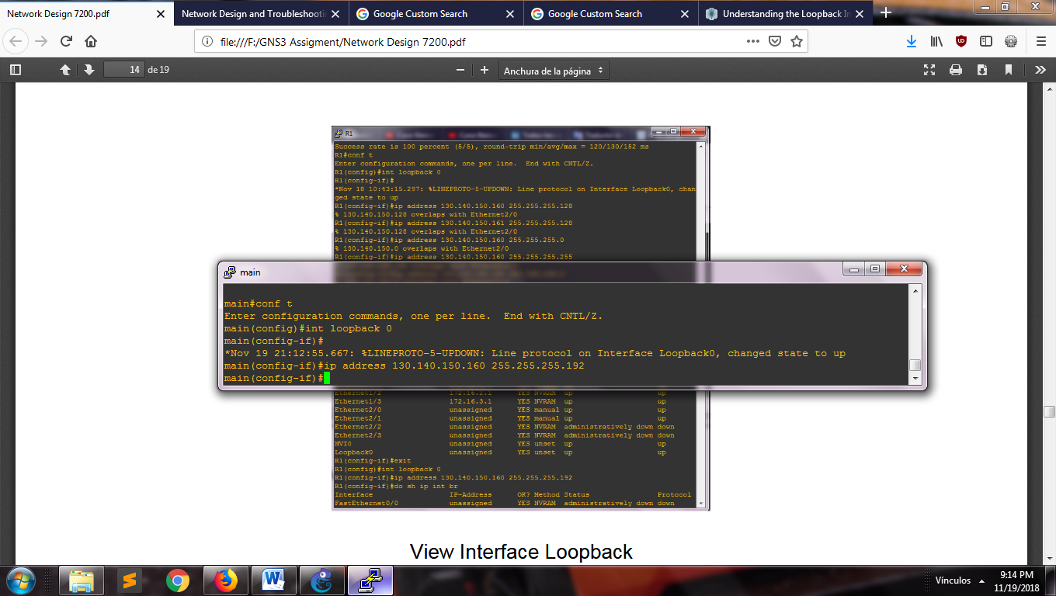

1. Command lines for the loopback connection

Having all the routers connected and configured, we try the connection exiting between the components. The next image shown the communication exiting between the network

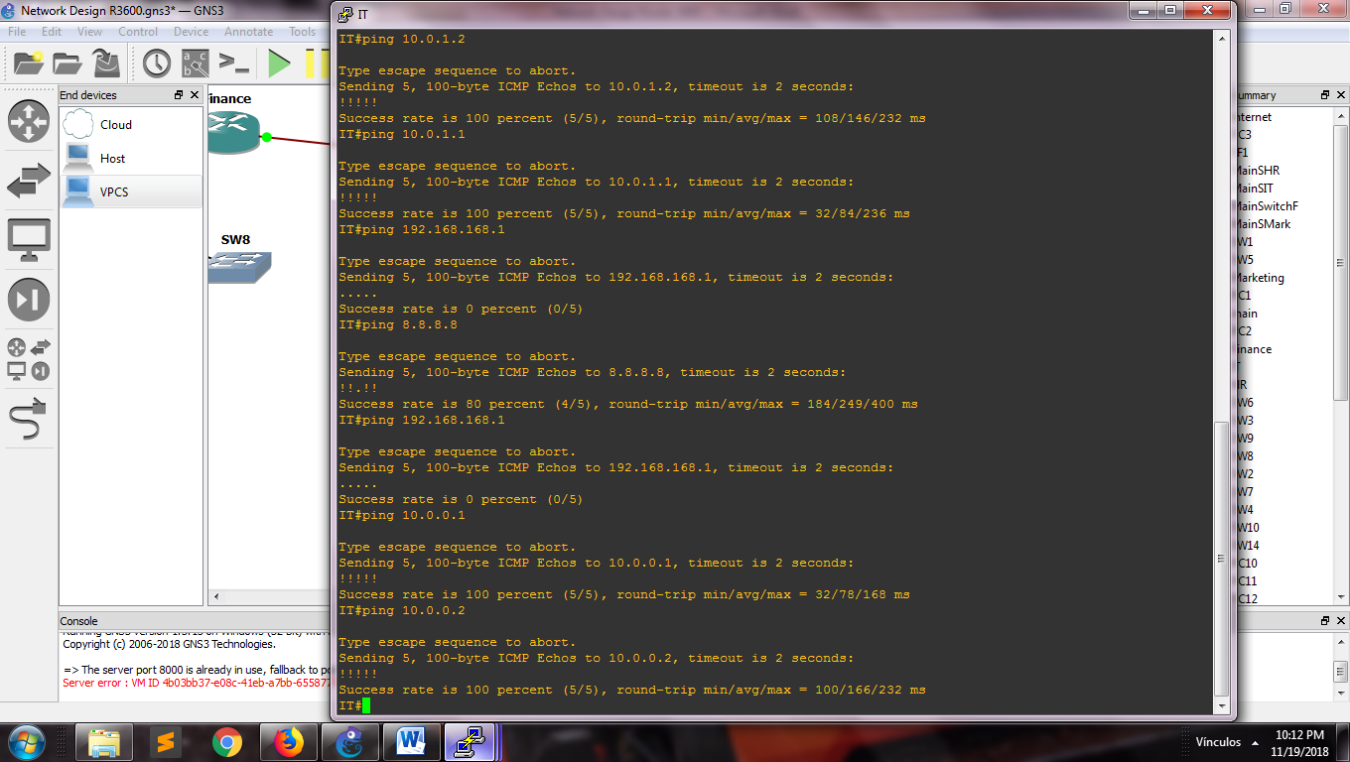

1. Checking the connection toward the routers and the internet

**REFERENCES**

* cisco.com, (2018). *Configure Commonly Used IP ACLs*. Available at: <https://www.cisco.com/c/en/us/support/docs/ip/access-lists/26448-ACLsamples.html>
* gns3.com, (2018). *Connect GNS3 to the Internet (local server)*. Available at: <https://docs.gns3.com/1vFs-KENh2uUFfb47Q2oeSersmEK4WahzWX-HrMIMd00/index.html>
* gns3vault.com, (2010). *PPP Authentication.* Available at: <https://gns3vault.com/hdlc-ppp/ppp-authentication/>
* juniper.net, (2018). *Understanding the Loopback Interface.* Available at: <https://www.juniper.net/documentation/en_US/junos/topics/concept/interface-security-loopback-understanding.html>
* smartpctricks.com, (2014). *How to Calculate Idle PC Value in GNS3 Network Simulator 0.8.6?*. Available at: <http://www.smartpctricks.com/2014/05/calculate-idle-pc-value-in-gns3.html>